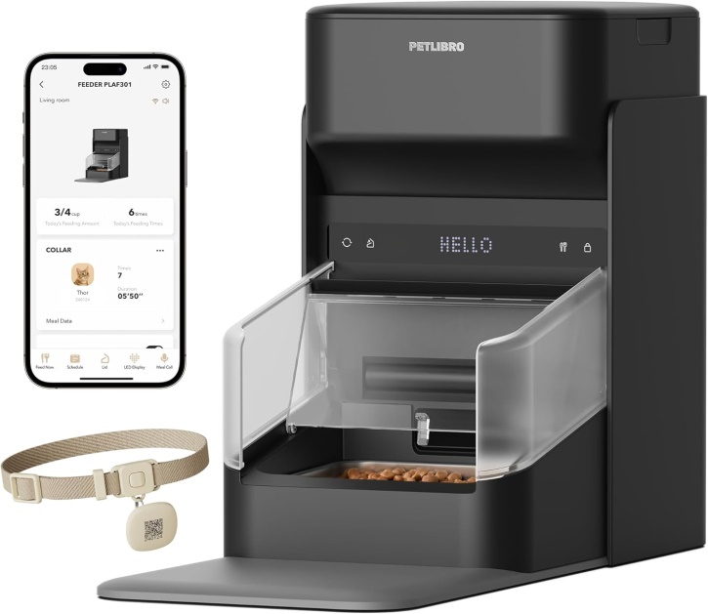


Visit the PETLIBRO Store

PETLIBRO RFID Automatic Cat Feeder, Collar Sensor for Personalized Meals, Cats Recognition, Diet Tracking and Anti-Stealing for Multi-Pets Homes and Different Diets, Wi-Fi Programmable Food Dispenser

LINK
https://amzn.to/4xjzNQB

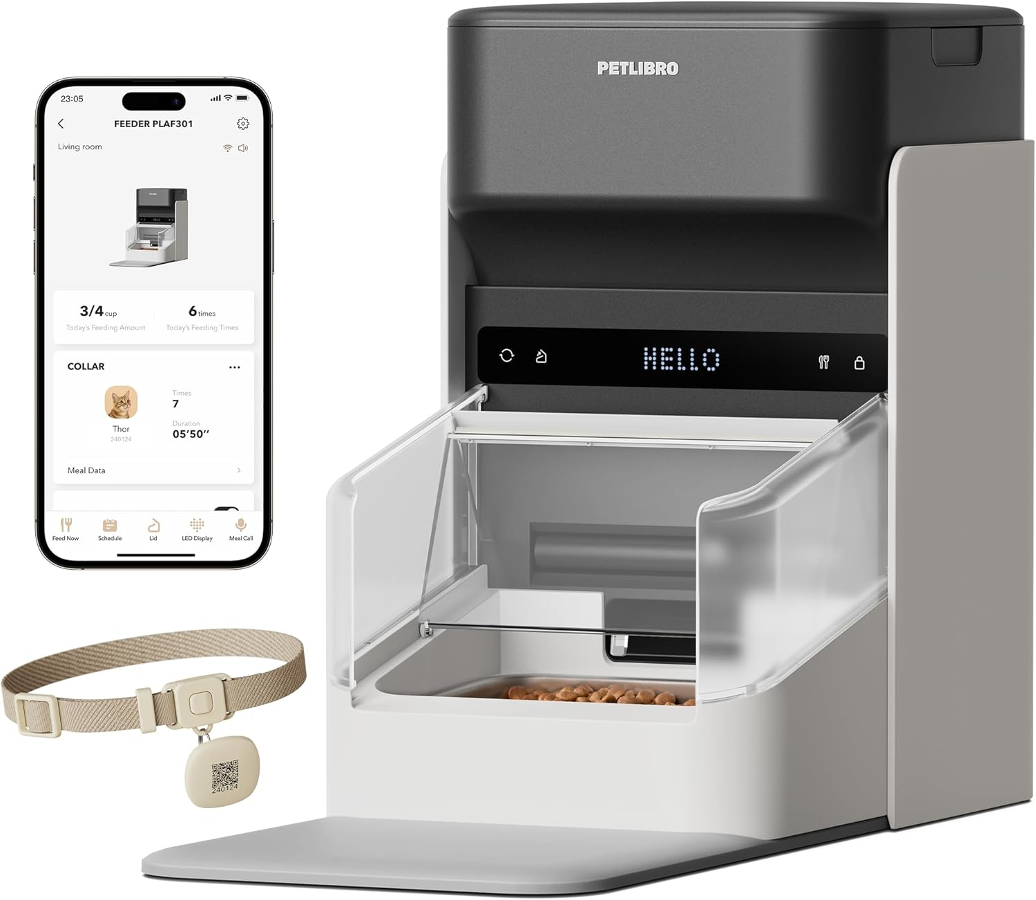

PETLIBRO (WHITE_

Visit the PETLIBRO Store

PETLIBRO RFID Automatic Cat Feeder, Collar Tag-Activated Personalized Meals, 5G&2.4G Wi-Fi Programmable Cat Food Dispenser with Cats Recognition & Diet Tracking for Multi-Pet Homes and Different Diets
LINK AMAZONE
https://amzn.to/4zDdNBs

3-
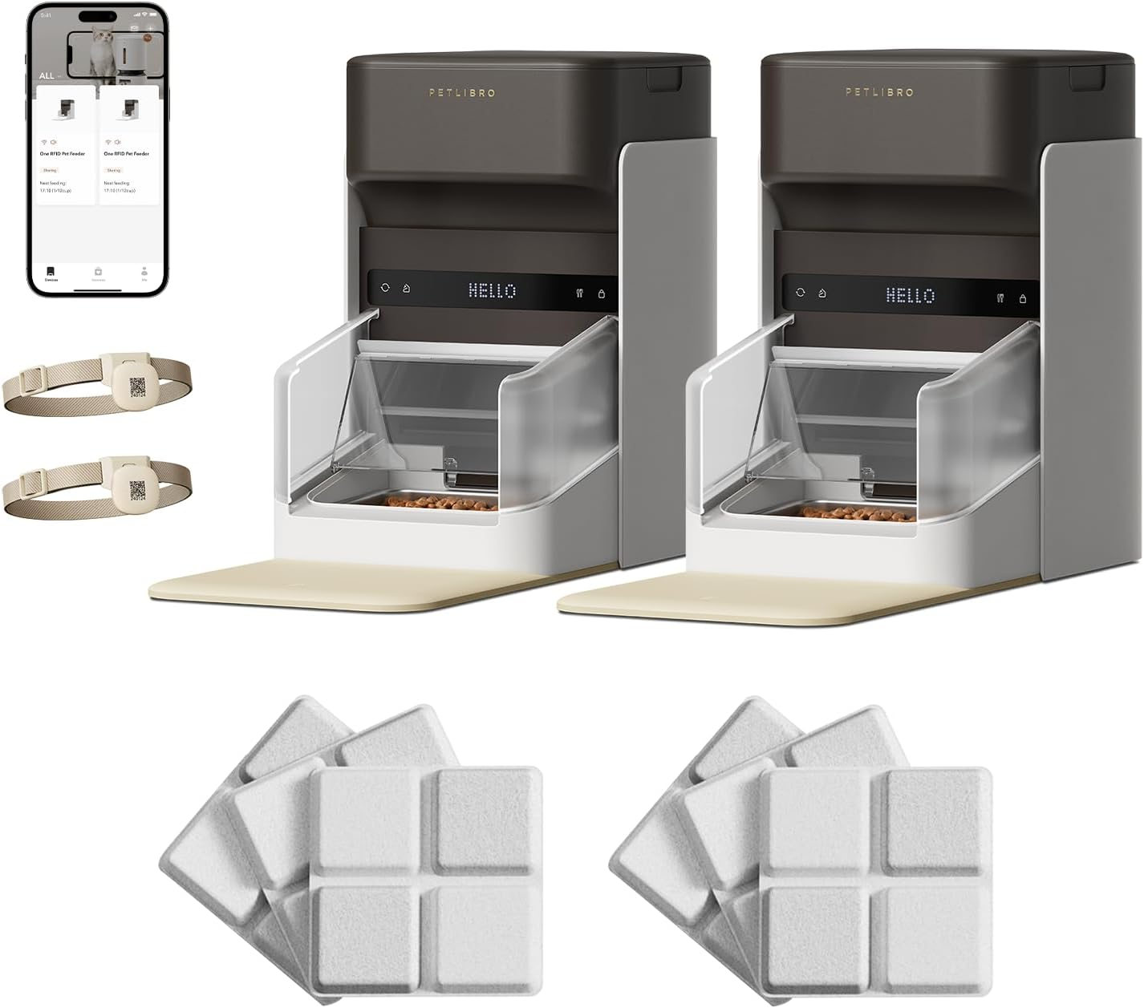


Visit the PETLIBRO Store

Bundle of PETLIBRO Upgraded RFID Automatic Cat Feeder, 2 Packs 5G Wi-Fi Automatic Pet Feeder, 3L Auto Cat Feeder App Control with Light Collar Tag + PETLIBRO 6 Packs Pet Food Desiccant Bag
LINK
https://amzn.to/4giMXHw

